Text Size

1)
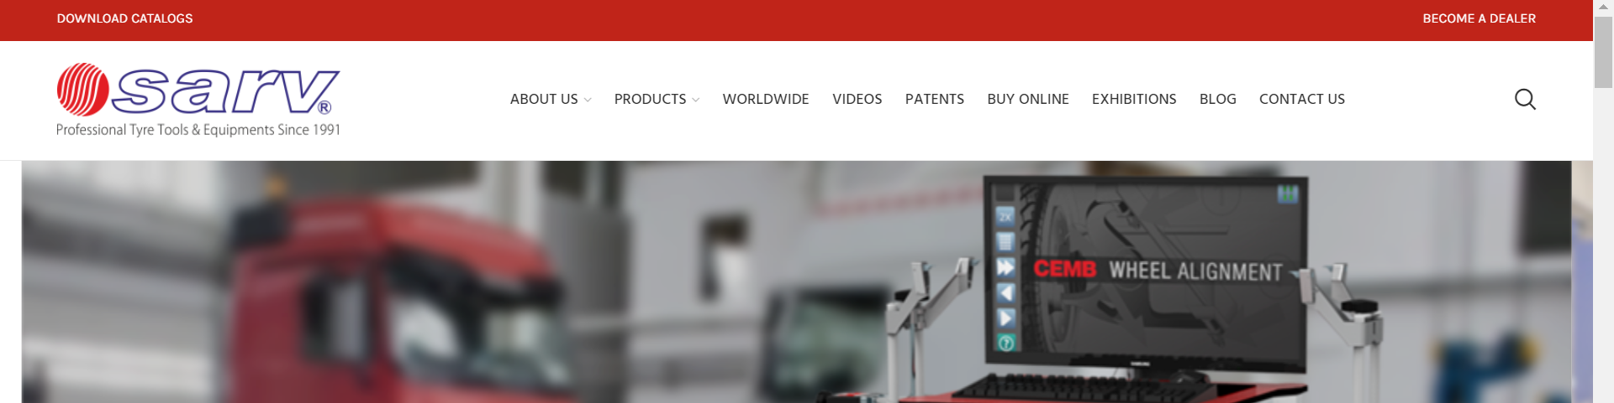

https://garageequipments.com/dealer/
2)Text Size and Color to black
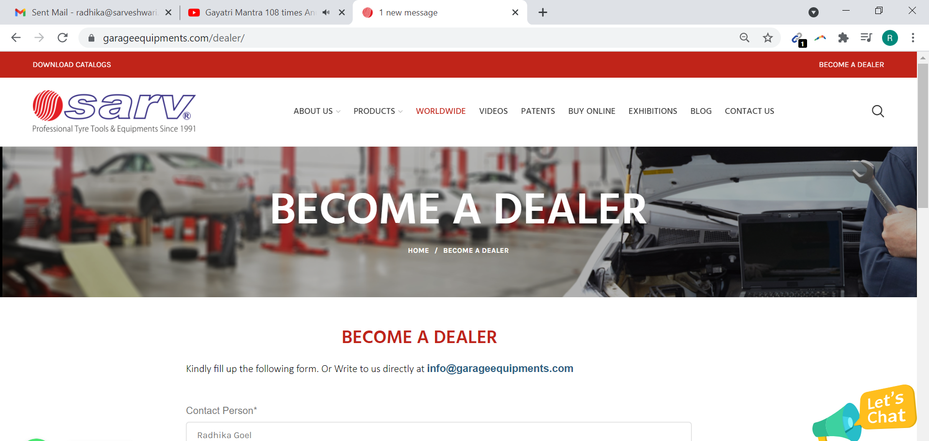

3)Animation Not working- Please increase text size.
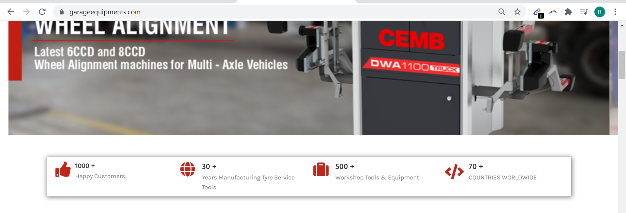
4) Please remove the stars from the image. This image size is also different from other images.
Change Left and Right Pics, there are not as per the size. I will Send you again. If it is still stretched send me a size I will get made again.

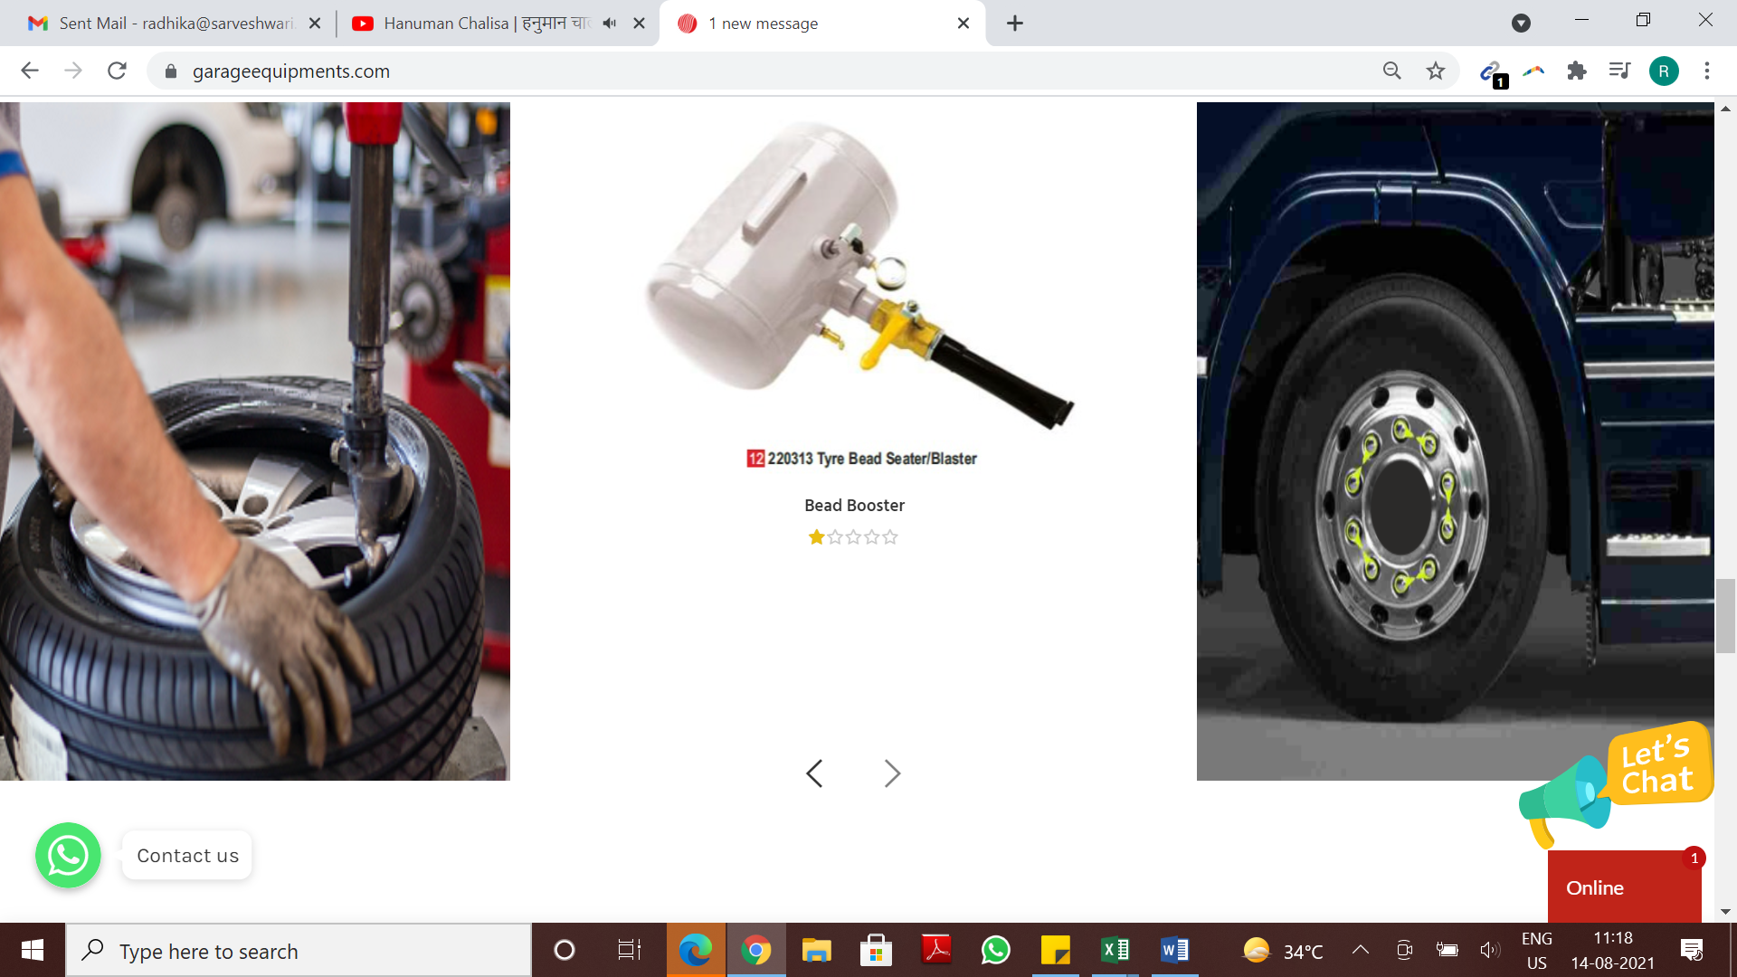

5) Please add “FULL LENGTH” Banners , Back to back
Also Kindly write the text if possible , because it has keywords.
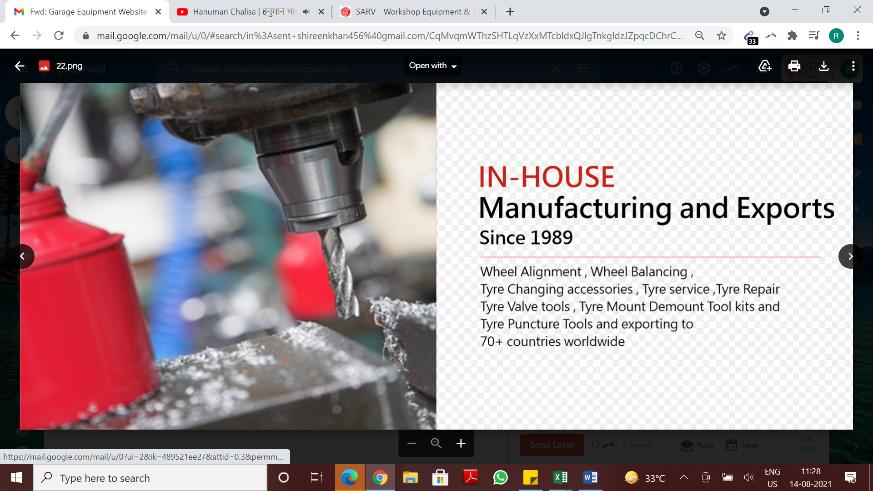
If you can type this as it has all keywords
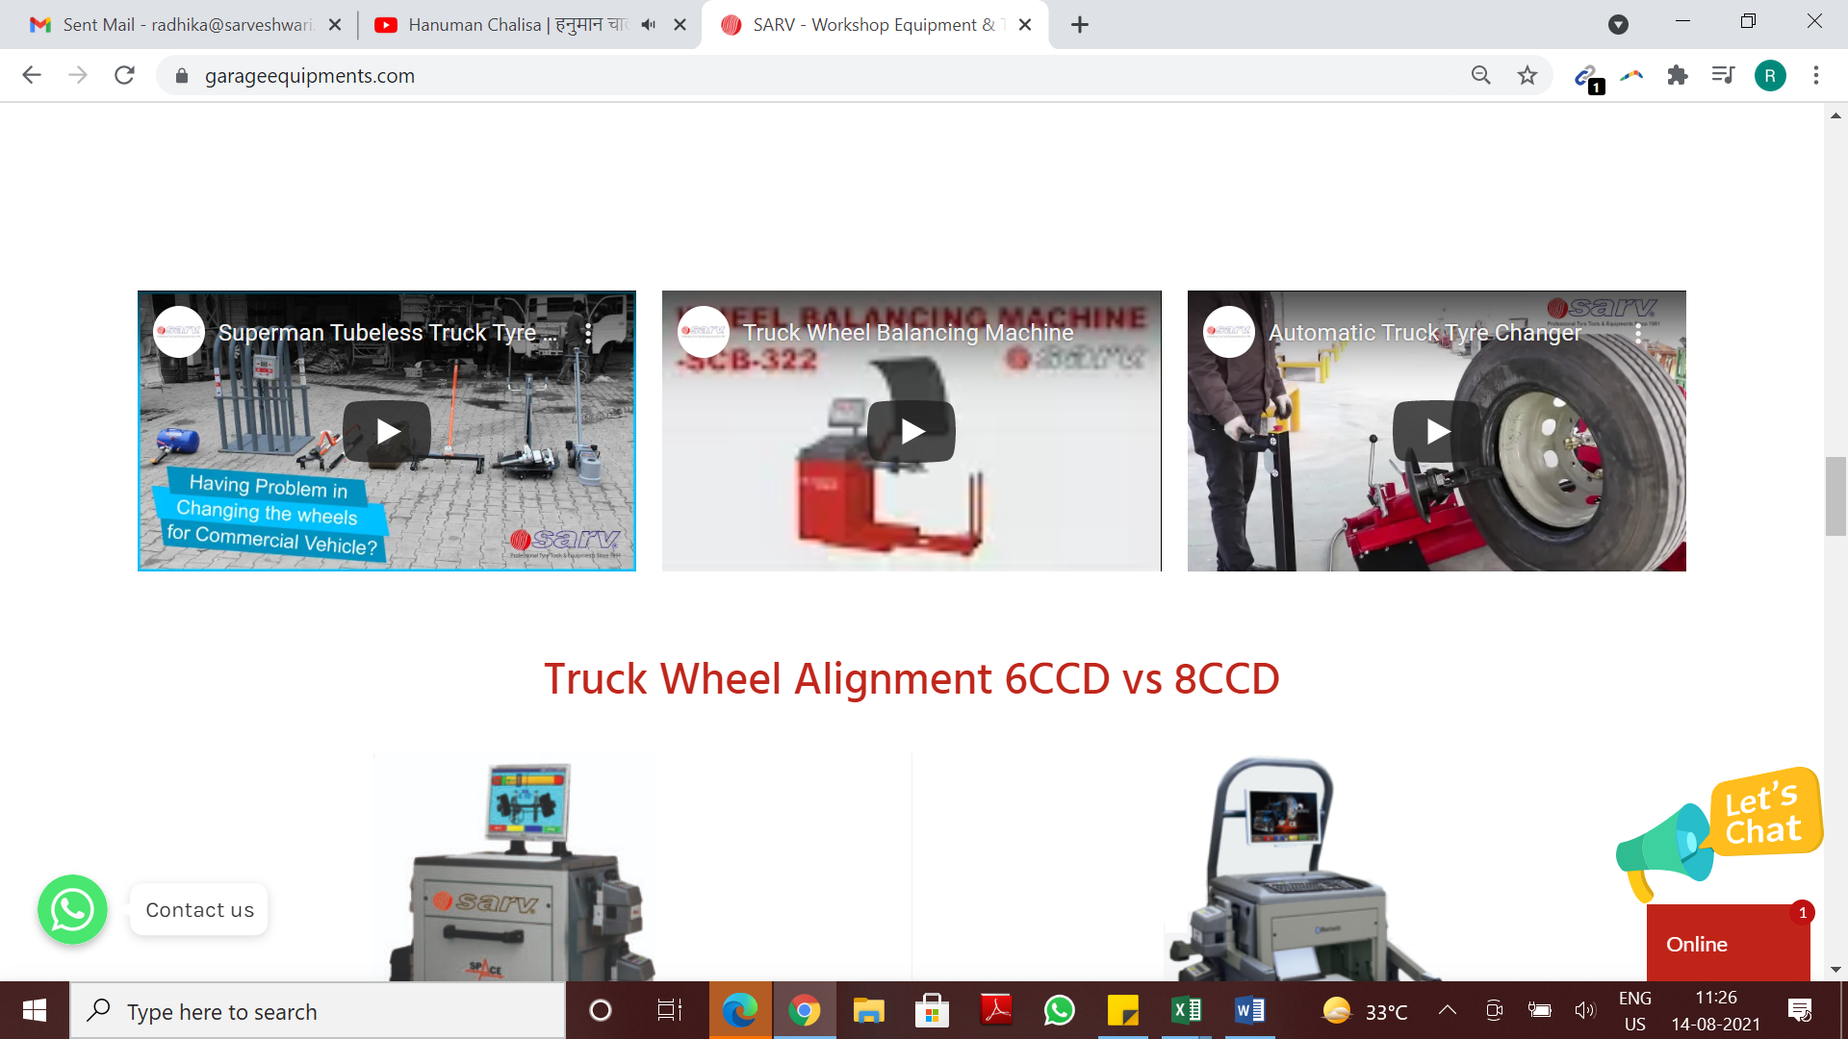
5) Make in one line both in Blog and NEWs
Need Topic name here instead of posted by and products manager
Need Topic name here instead of posted by and products manager
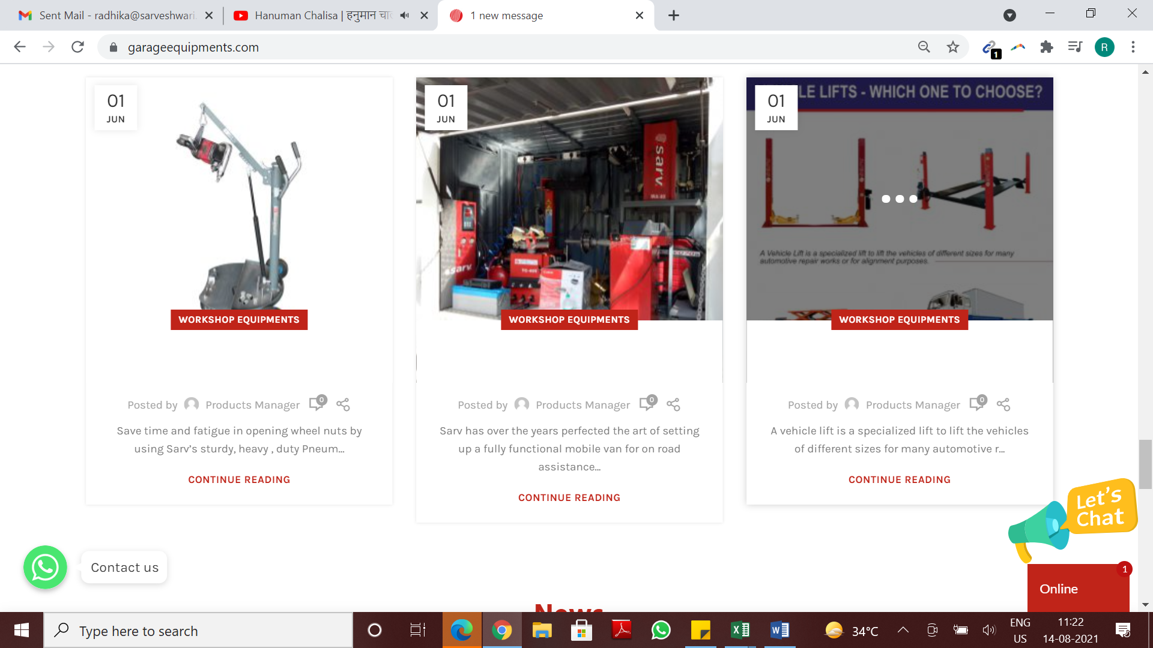

6) Have given you footer image already, Please change intro :
Sarv Delhi, Premium Suppliers & Manufacturers of Wheel Alignment Machine, Wheel Balancing Machines, Tyre Changing machines , Lifts, Nitrogen, Vehicle Exhaust Extraction Systems & Tyre Service Tools since 31 Years.
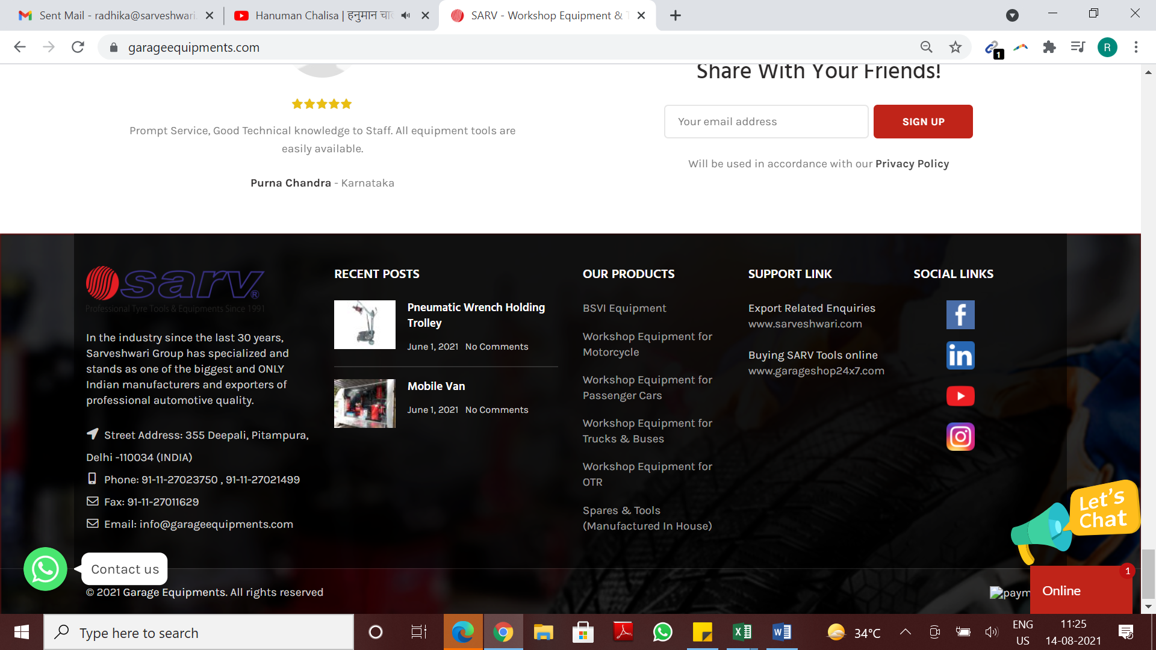
Remove Payment Icon
Remove Payment Icon

7) Lot of distance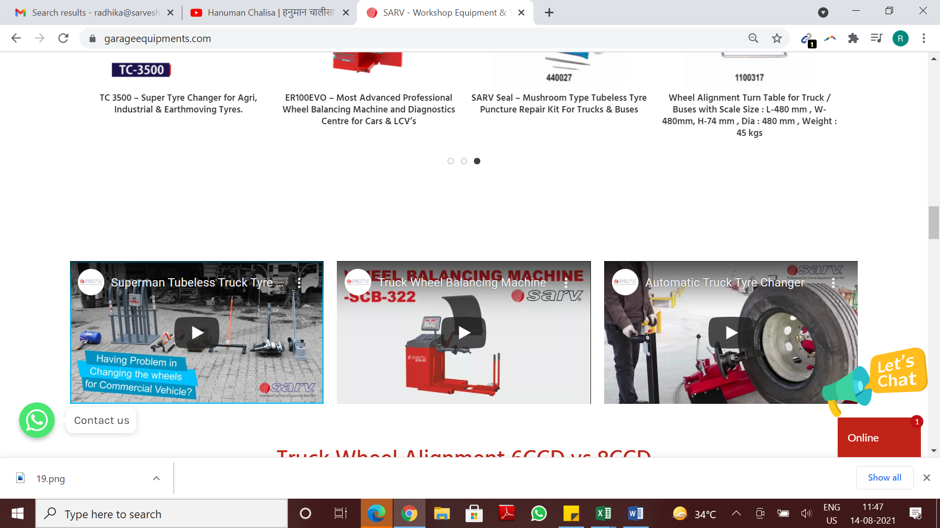
7) All headings on home page are differently designed
Please keep this format below (Capitals)( IN maroon theme colour of course) and SAME animation and Distance!!

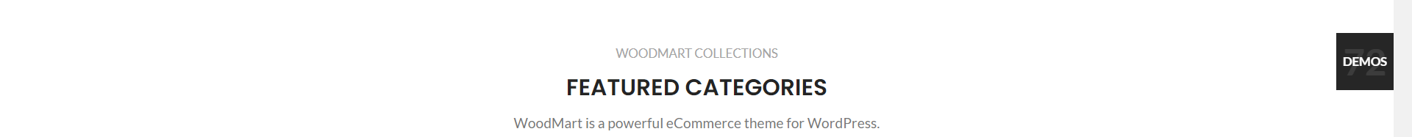
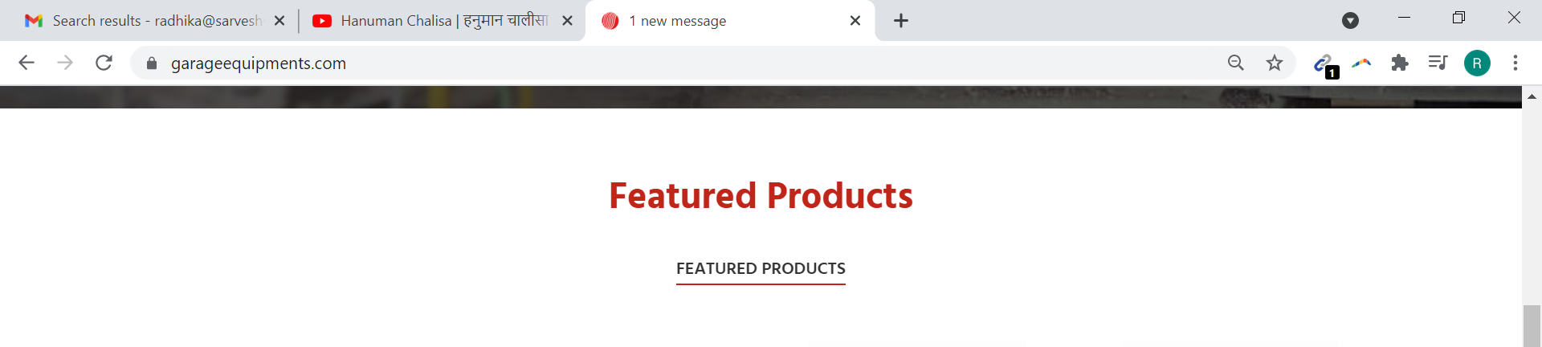

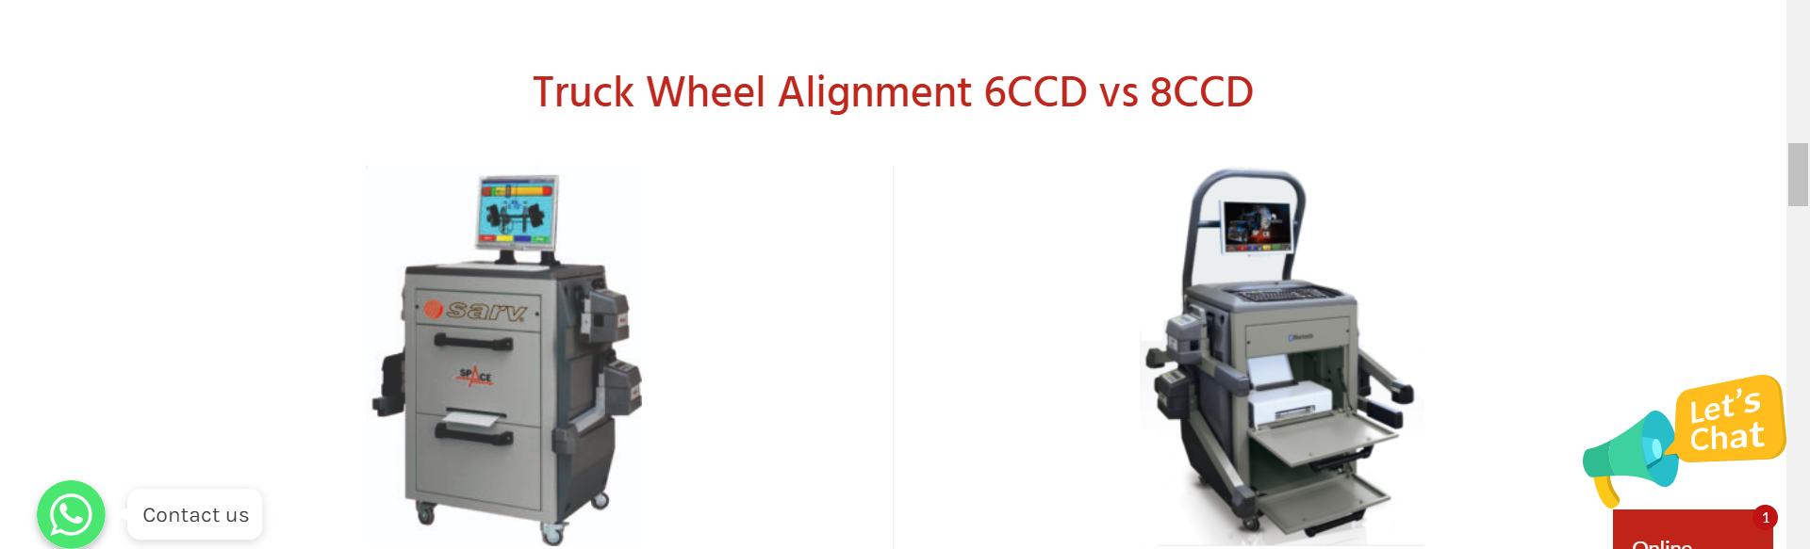

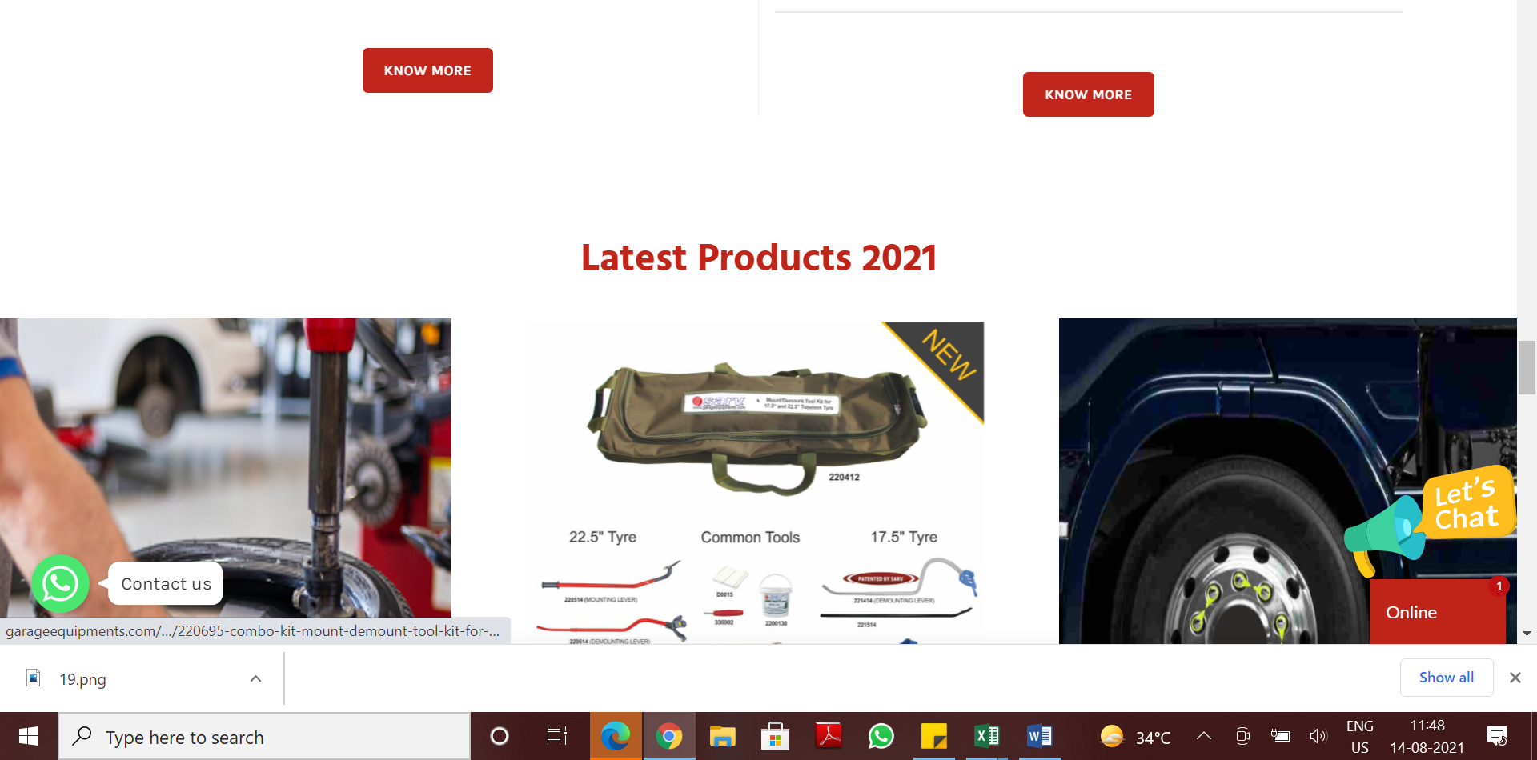
Distance
Distance
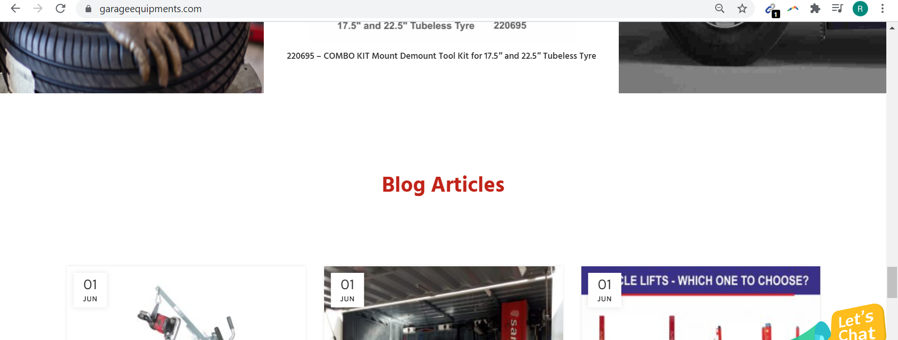

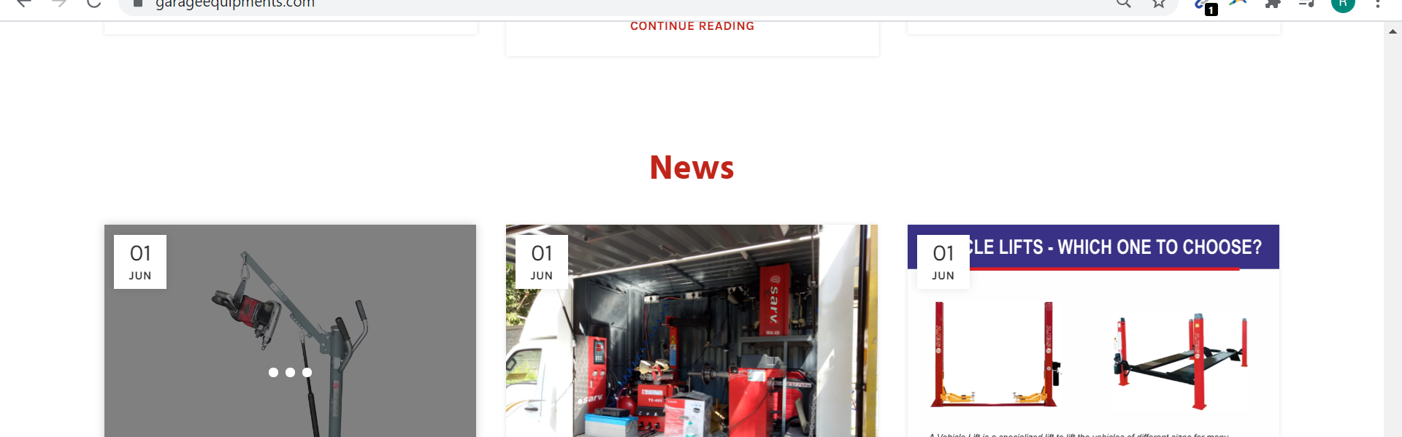

8) About us
Text Size , Make it black and Justification
https://garageequipments.com/about/
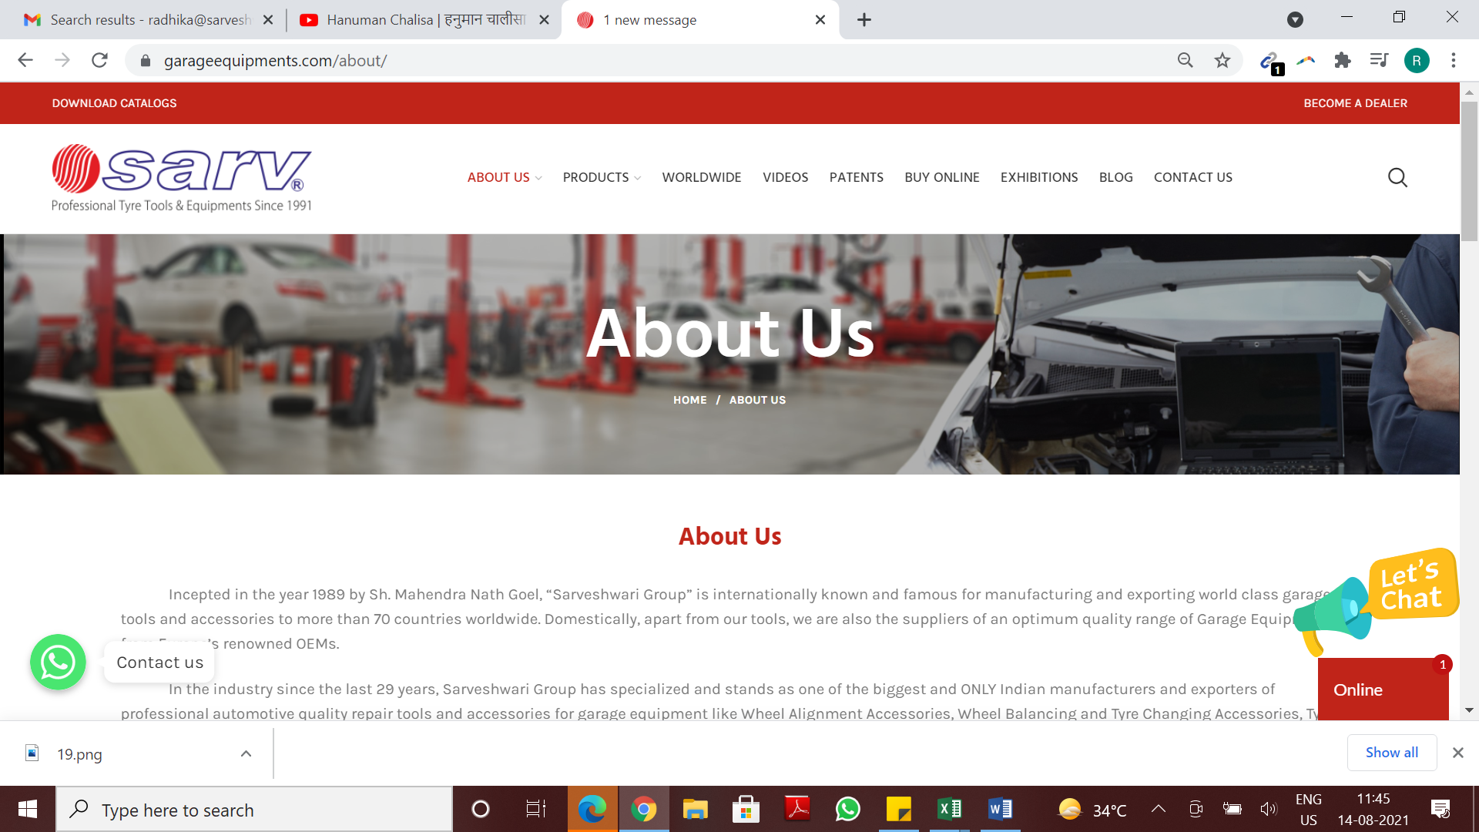

9) https://garageequipments.com/contact-us/
Reduce Box Size in all forms

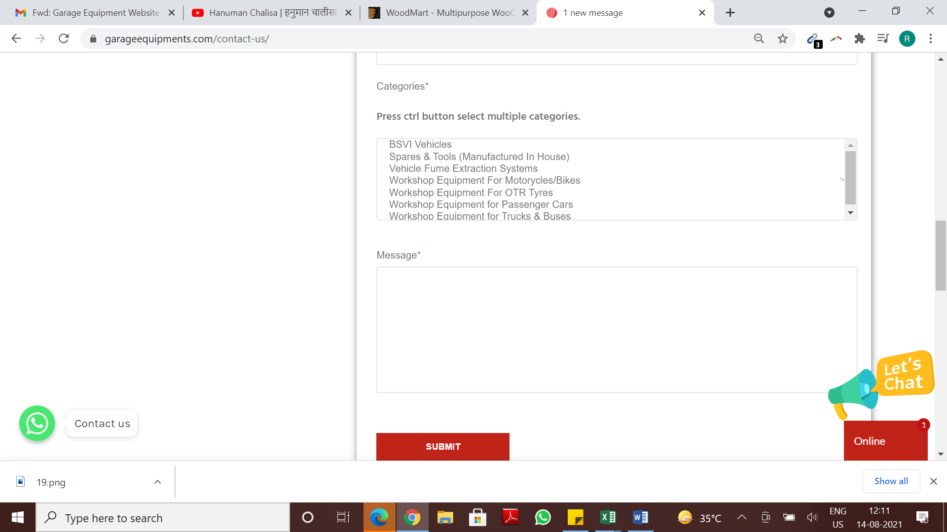

10) Add any other banner as contact us is getting Cut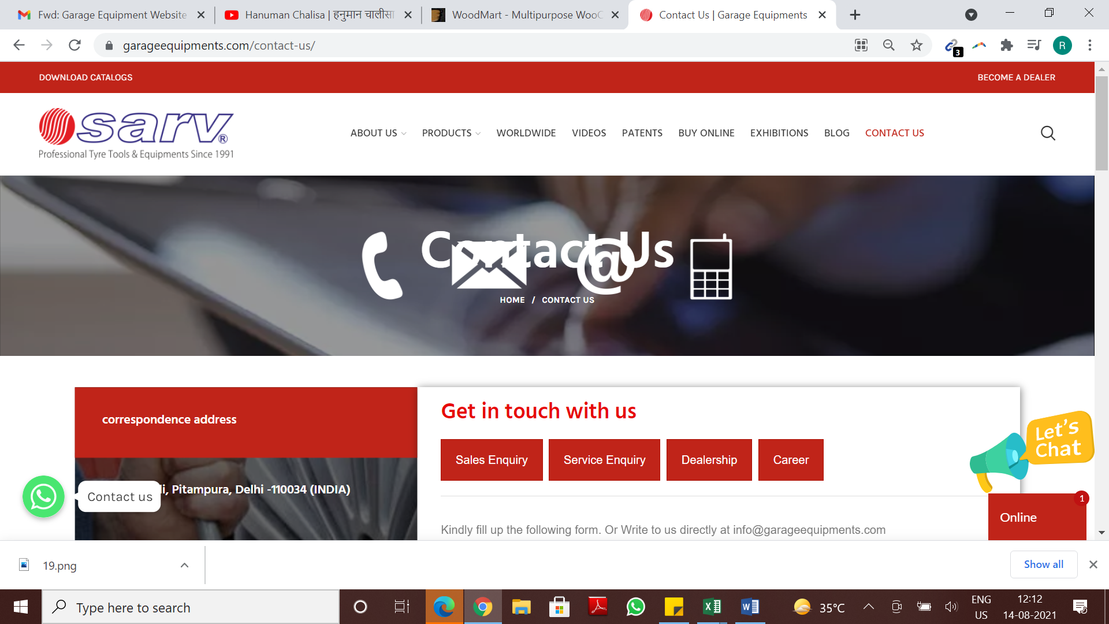

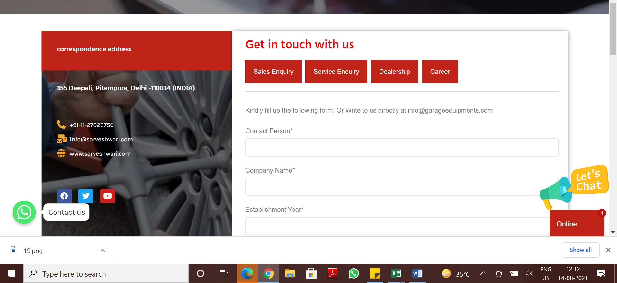
www.garageequipments.com
info@garageequipments.com
Correspondence Address

11) https://garageequipments.com/product-category/
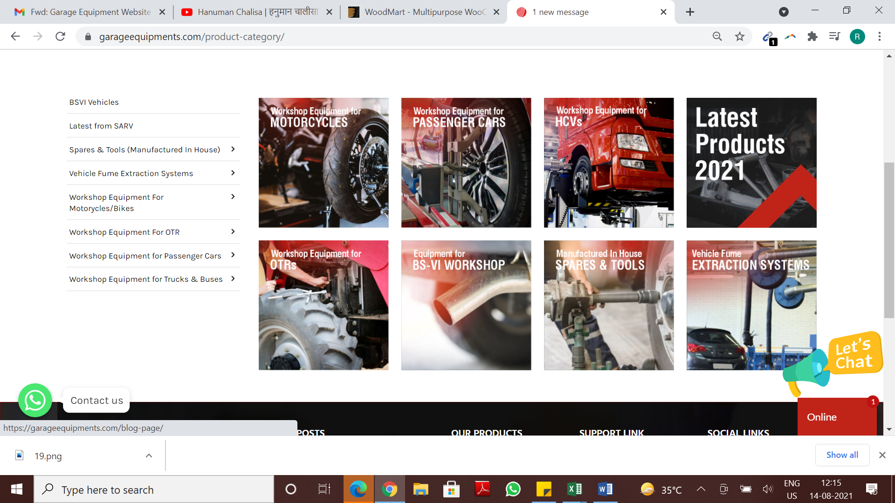
Increase Size
Category Design ( top red banner missing)
Box Size to increase

12) If Categories can come in white when red box comes
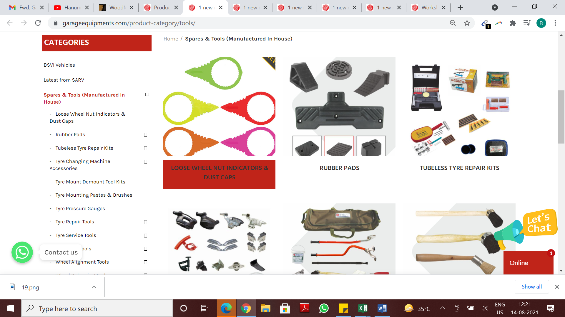

13) Add to wishlist is coming , also Square boxes are coming instead compare and quick view logo.
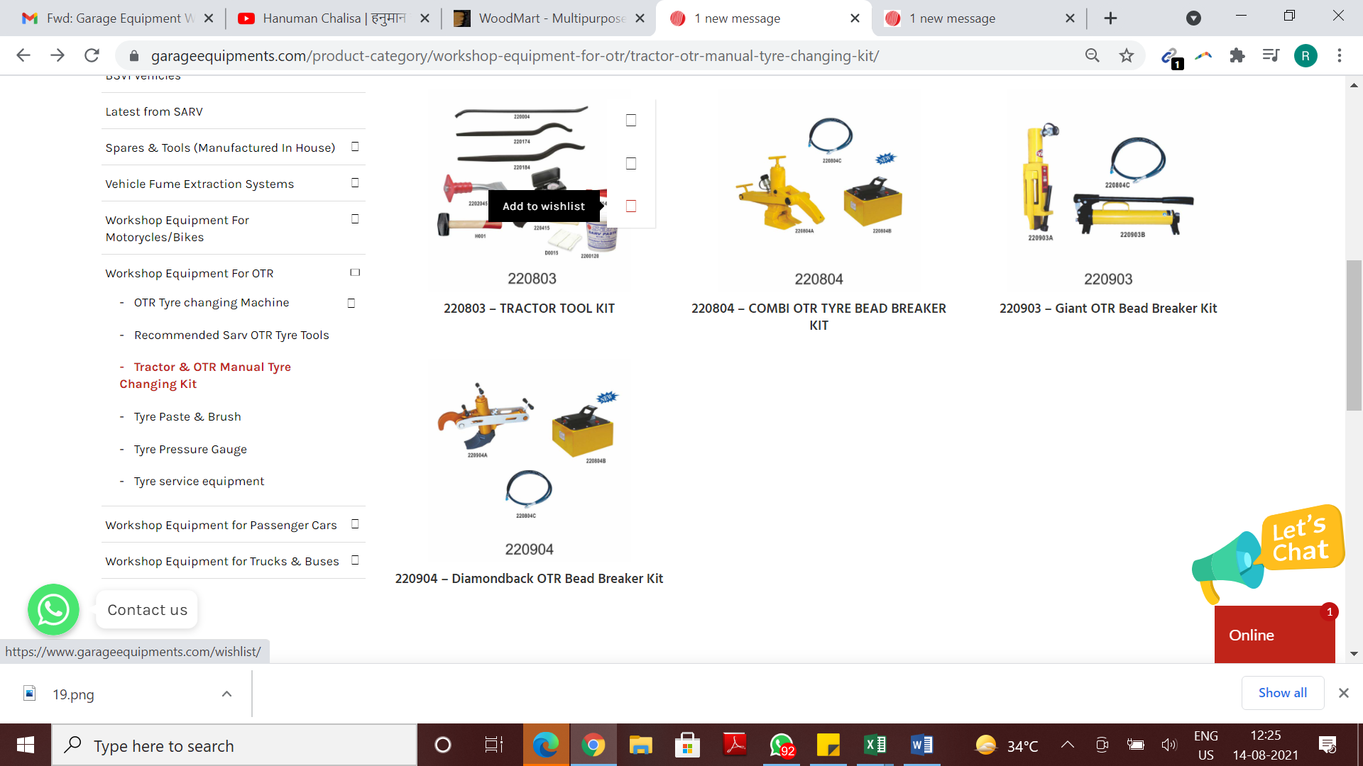

14) Only square boxes are coming in left category
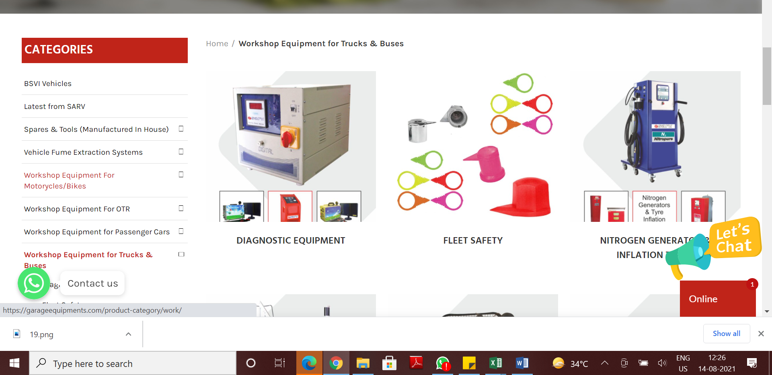

15) Video Icon is not clear -https://www.garageequipments.com/product/dl-1500-tyre-changing-machine/
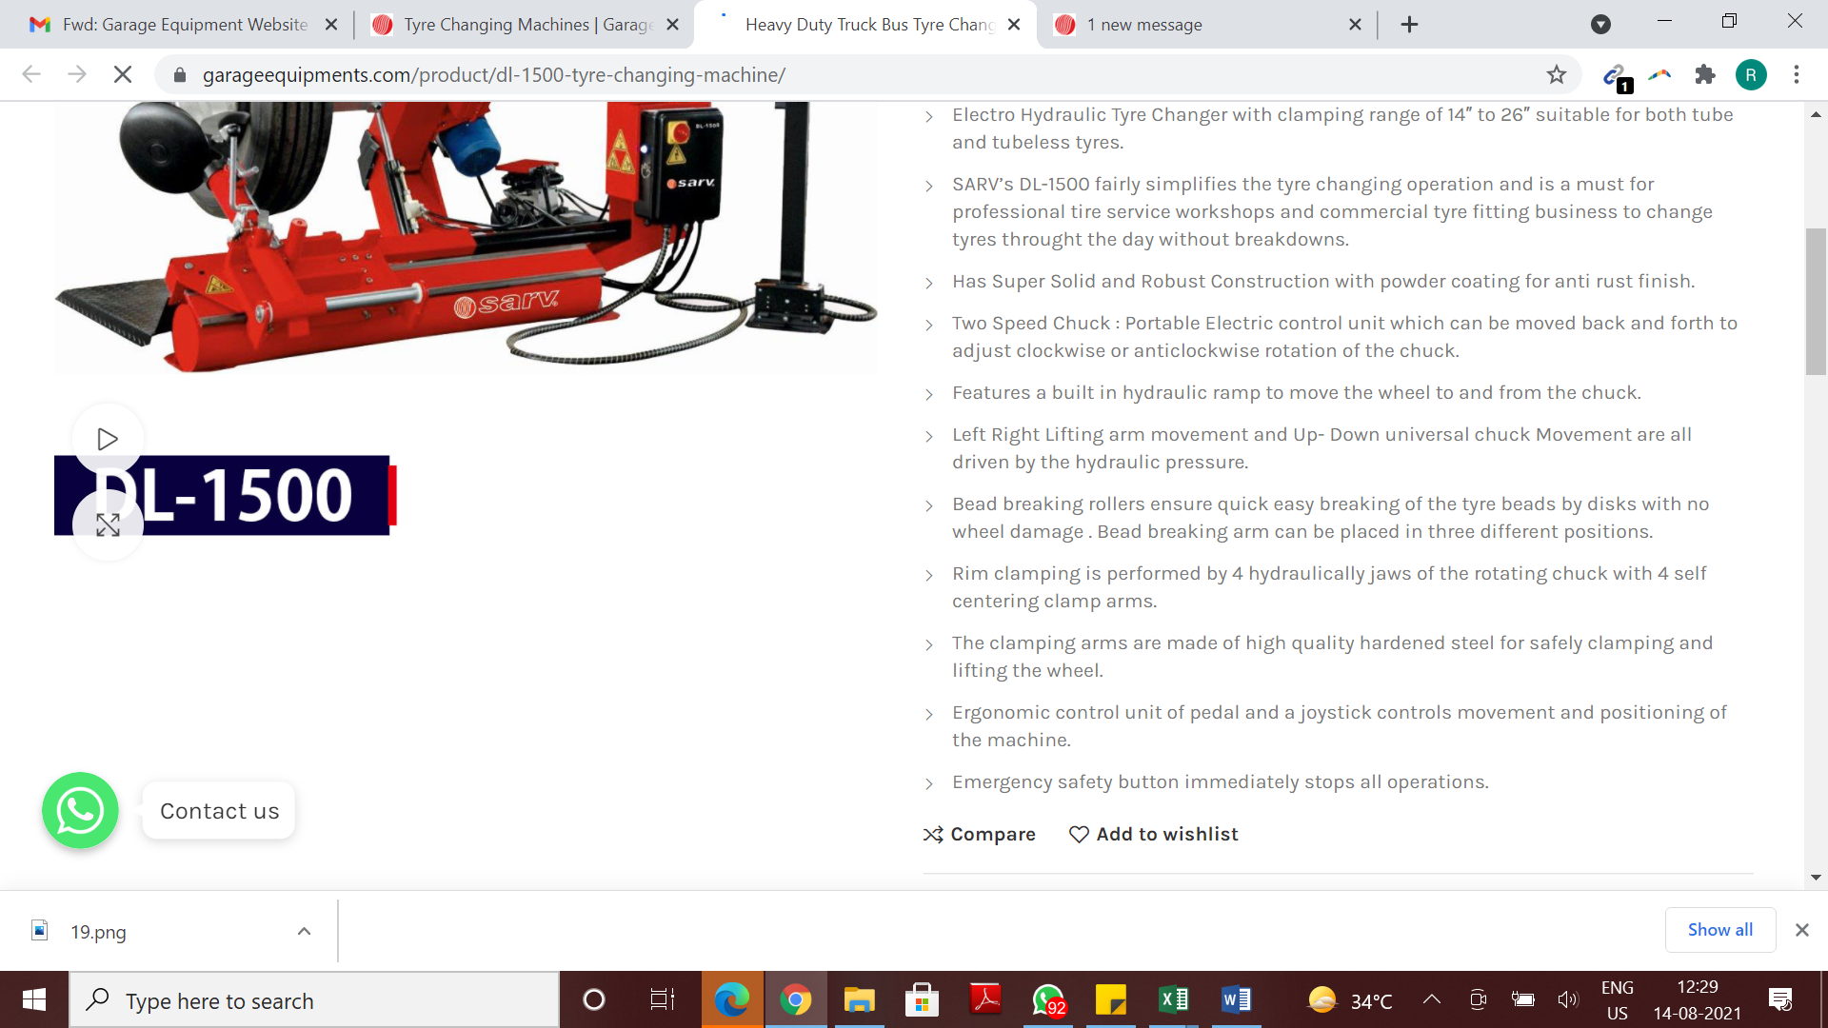
Color of the text to be Black.
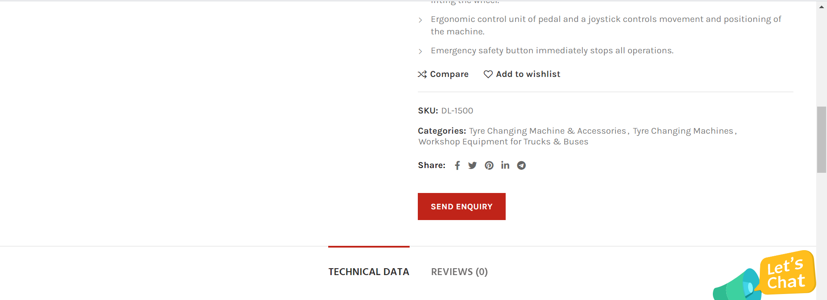
Links not working. You already have social links in the footer

16)

